***High Level Design – Interview Scheduling System***

**Created by:** Team Alpha

**Version:** 1.1.0

**Date:** 19-04-2022

**Table of Contents**

**1. Introduction** **iii**

**2. System Architecture** **v**

2.1Email Service **vii**

**3. Database Diagram** **xiii**

**4. Database Dictionary** **xv**

**5. Services** **xvii**

**6. Modification History** **xviii**

# **Introduction**

This document provides a detailed design of the system. It starts with the design principle used, lists the non-functional requirements and a detail description about the subsystem or components which comprise the system and their interactions.

# **System Architecture**

The Interview Scheduling System can be divided into the following subsystems.

* + A subsystem for logging in, create a new user, edit the details etc.
  + The Interview Scheduling system which can provide access for interviewer, schedule drive, cancel drive, create pools, manage pools, view statistics of interviewers.

## **Architecture Description**

## **Email Service**

Email service is an essential component in product development. Email Service aims to provide an API for sending email. This component enables the user to send an email with SMTP or SMTP over SSL protocol. And also, it allows to store the email permanently in hard disk with eml file format.

## **Component Description**

|  |  |
| --- | --- |
| Component Name | Email |
| Responsibilities | Sends Invite mails |
| Use Cases Affected | Nil |
| Identified Issues | Nil |

# **Database Diagram**

A subsystem for logging in,

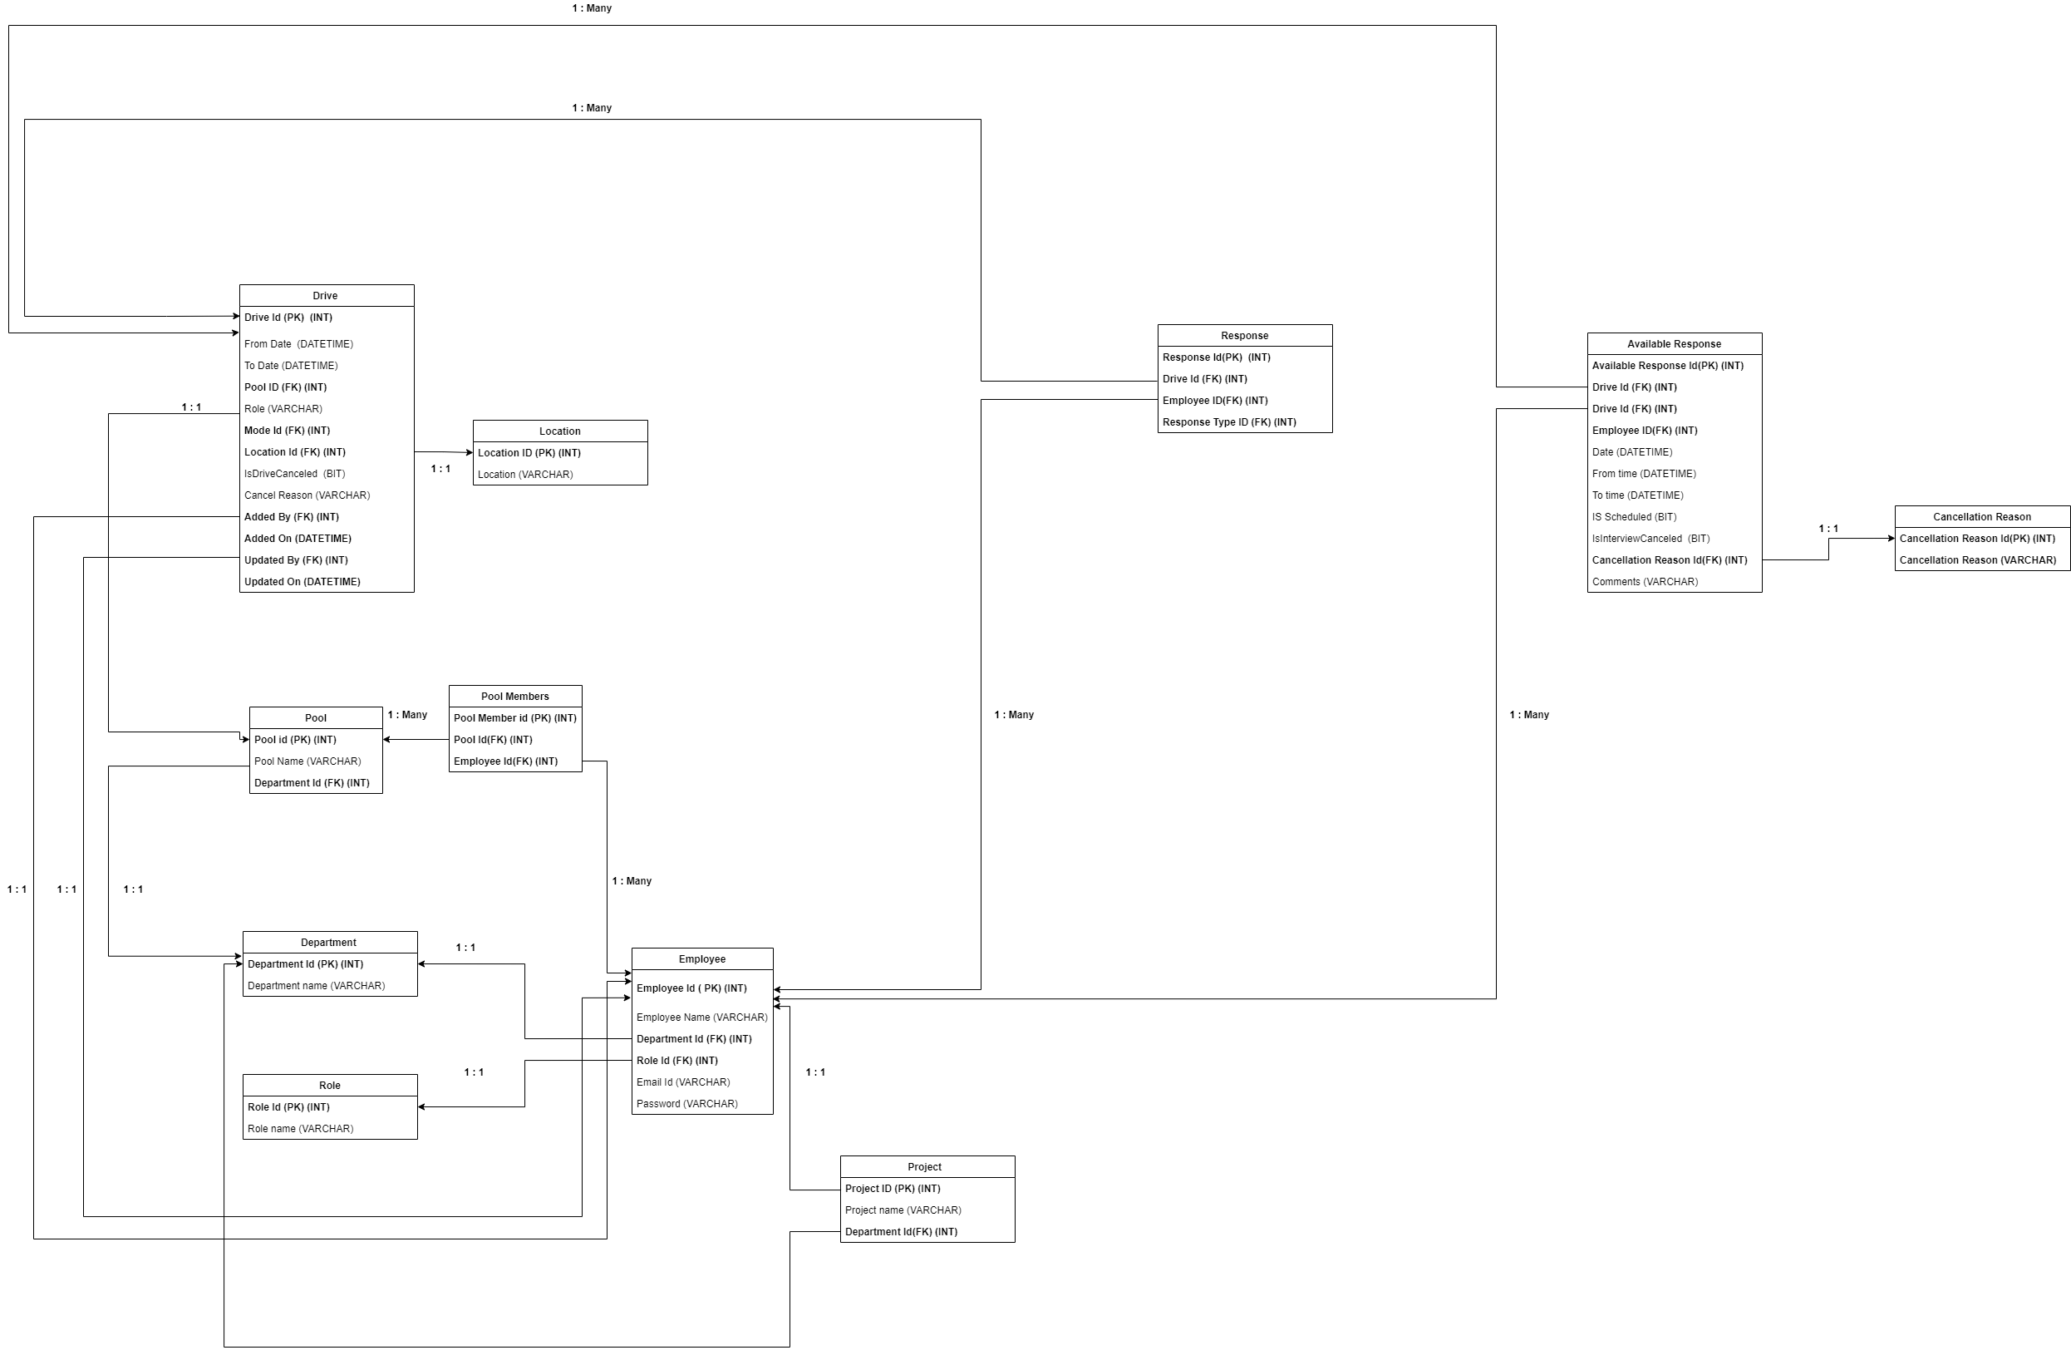

Physical Model

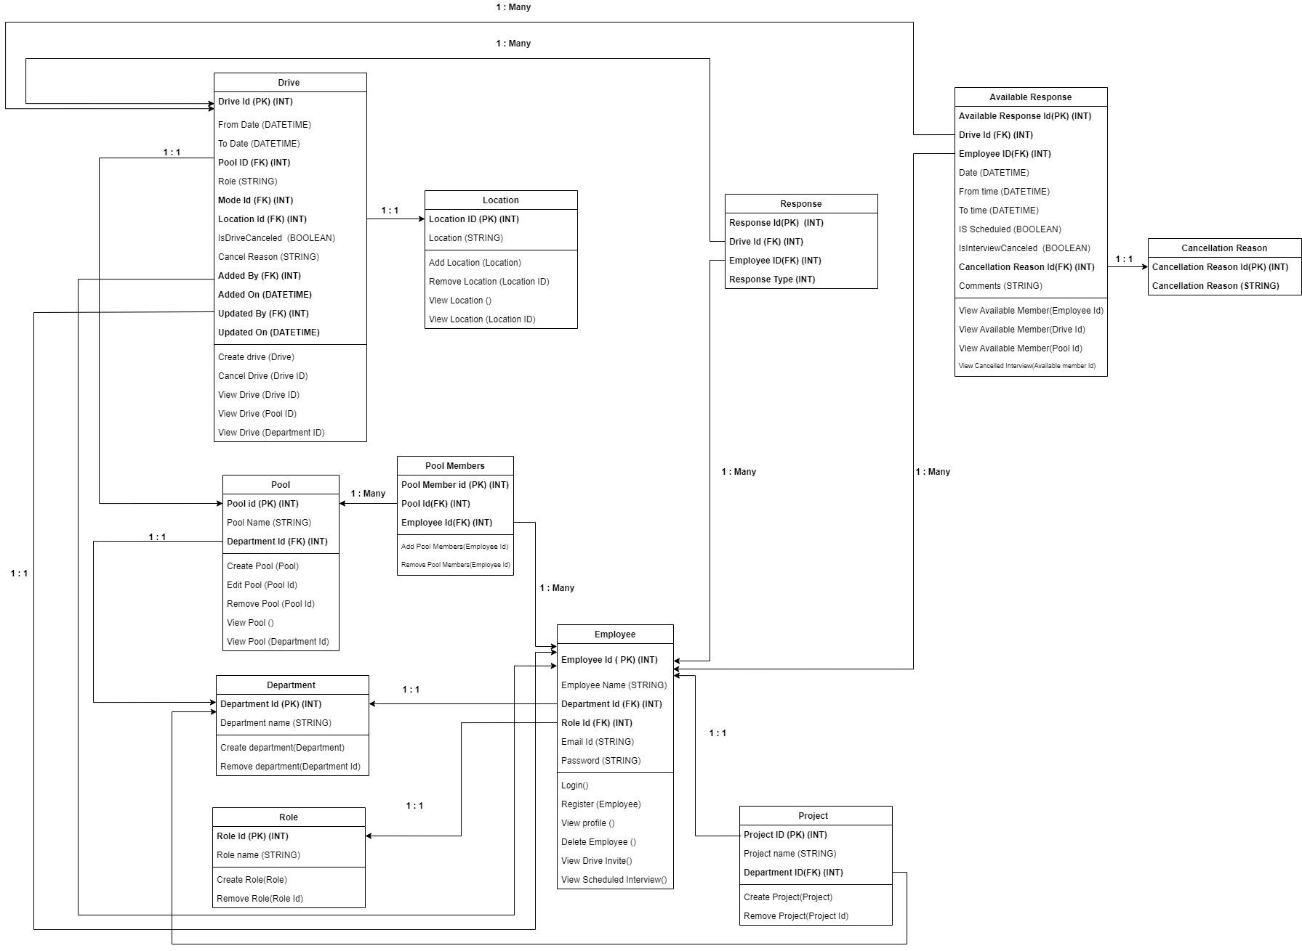

Logical Model

Class Diagram

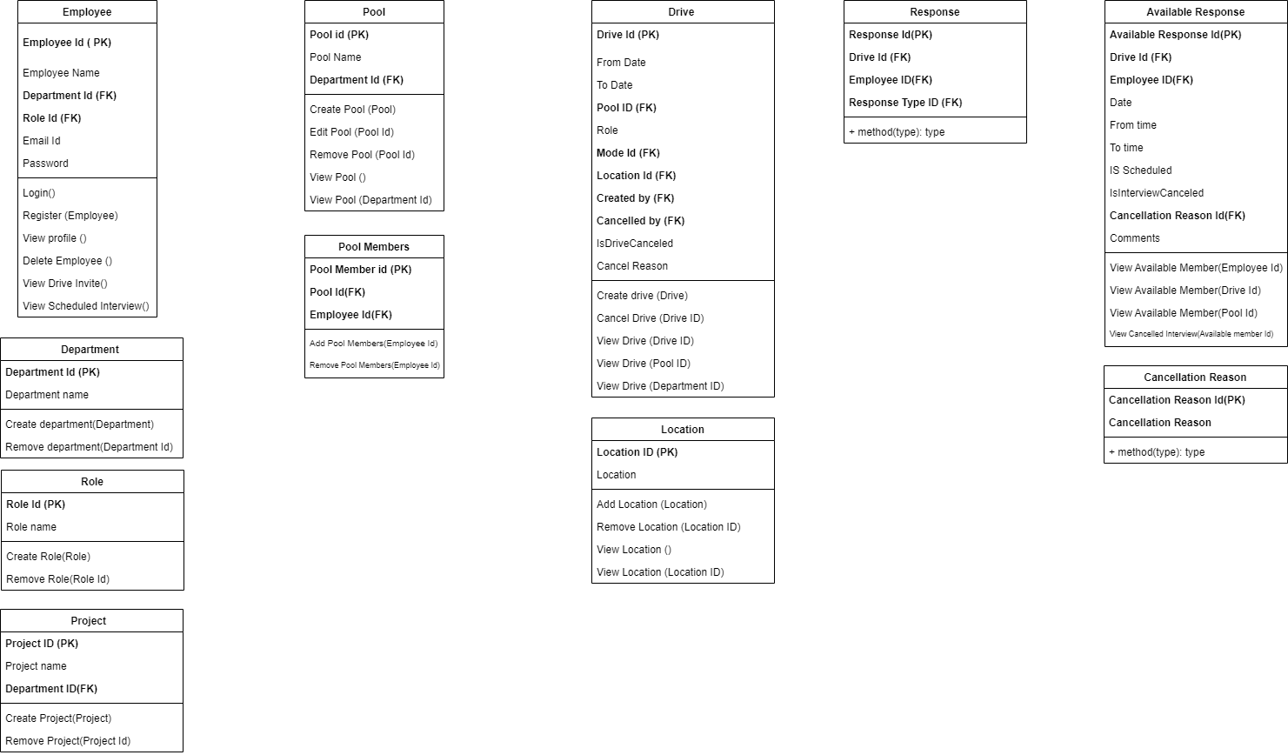

# **Database Dictionary**

**Table 1. DRIVE**

|  |  |  |  |
| --- | --- | --- | --- |
| **Field Name** | **Data type** | **Constraints** | **Description** |
| Drive ID | integer | Primary key | ID for each Drive |
| From Date | Int | Not null | Beginning date of Drive |
| To Date | Int | Not null | End date of Drive |
| Pool ID | Int | Foreign Key | ID for each Pool |
| Role | nVarchar (20) | Not null | Role of an Employee |
| Mode ID | Int | Foreign Key | ID for each Mode |
| Location ID | Int | Foreign Key | ID for each Location |
| Added by | Int | Foreign Key | Name of the Created person the drive |
| Added on | DateTime | Not null | Date & Time of the drive |
| Updated by | Int | Foreign Key | Name of the person updated the drive |
| Updated on | DateTime | - | Updated Date & Time of the drive |
| Is Drive Cancelled | Bool | Not null | Flag to Find drive status |
| Cancel Reason | nVarchar (500) | - | Reason for Cancellation of Drive |

**Table 2. POOL**

|  |  |  |  |
| --- | --- | --- | --- |
| **Field** | **Data type** | **Constraints** | **Description** |
| Pool ID | integer | Primary key | ID of the Pool |
| Pool Name | nvarchar (50) | Not Null | Name of Pool |
| Department ID | Int | Not null | ID of the Department |

**Table 3. DEPARTMENT**

|  |  |  |  |
| --- | --- | --- | --- |
| **Field** | **Datatype** | **Constraints** | **Description** |
| Department ID | Int | Primary key | ID of each Department |
| Department Name | nvarchar (50) | Not null | Name of department |

**Table 4. ROLE**

|  |  |  |  |
| --- | --- | --- | --- |
| **Field** | **Datatype** | **Constraints** | **Description** |
| Role ID | Int | Primary key | ID of each Role |
| Role Name | nvarchar (50) | Not null | Name of Role |

**Table 5. EMPLOYEE**

|  |  |  |  |
| --- | --- | --- | --- |
| **Field** | **Datatype** | **Constraints** | **Description** |
| Employee ID | Int | Primary Key | ID for each Employee |
| Employee Name | nvarchar (30) | Not null | Name of Each Employee |
| Department ID | Int | Foreign Key | ID of each Department |
| Role ID | Int | Foreign Key | ID of each Role |
| Email ID | nvarchar() | Not null | Email ID of Each Employee |
| Password | nvarchar() | Not null (Minimum 8) | Not null |

**Table 6. PROJECT**

|  |  |  |  |
| --- | --- | --- | --- |
| **Field** | **Datatype** | **Constraints** | **Description** |
| Project ID | Int | Primary Key | ID for each project |
| Project Name | varchar (50) | Not null | Name of each project |
| Department ID | Int | Foreign Key | ID of each Department |

**Table 7. LOCATION**

|  |  |  |  |
| --- | --- | --- | --- |
| **Field** | **Datatype** | **Constraints** | **Description** |
| Location ID | Int | Primary key | ID of each Location |
| Location | nvarchar (50) | Not null | Name of Location |

**Table 8. POOL MEMBERS**

|  |  |  |  |
| --- | --- | --- | --- |
| **Field** | **Data type** | **Constraints** | **Description** |
| Pool Member ID | Int | Primary key | ID of the Pool Member |
| Pool ID | Int | Foreign Key | ID of each Pool |
| Employee ID | Int | Foreign Key | ID for each Employee |

**Table 9. RESPONSE**

|  |  |  |  |
| --- | --- | --- | --- |
| **Field** | **Data type** | **Constraints** | **Description** |
| Response ID | Int | Primary key | ID of each response |
| Response type ID | Int | Foreign Key | ID of each Drive |
| Employee ID | Int | Foreign Key | ID for each Response Type |

**Table 10. AVAILABLE RESPONSES**

|  |  |  |  |
| --- | --- | --- | --- |
| **Field** | **Datatype** | **Constraints** | **Description** |
| Available Response ID | Int | Primary Key | ID for each Available Response |
| Drive ID | Int | Foreign Key | ID for each Drive |
| Employee ID | Int | Foreign Key | ID for each Response Type |
| Date | Int | Not null | Date of Response |
| From Time | Int | Not null | From Time |
| To Time | Int | Not null | To Time |
| Is Scheduled | Bool | Not null | Flag to Find drive status |
| Is Interview Cancelled | Bool | Not null | Flag to Find drive status |
| Cancellation Reason ID | Int | Foreign Key | Id for each cancellation Reason |
| Comments | nvarchar(500) | Not null | Comments for cancellation |

**Table 11. CANCELLATION REASON**

|  |  |  |  |
| --- | --- | --- | --- |
| **Field** | **Datatype** | **Constraints** | **Description** |
| Cancellation Reason ID | Int | Primary Key | ID of each Cancellation Reason |
| Cancellation Reason | nvarchar (50) | Not null | Reason for cancellation |

**SERVICES**

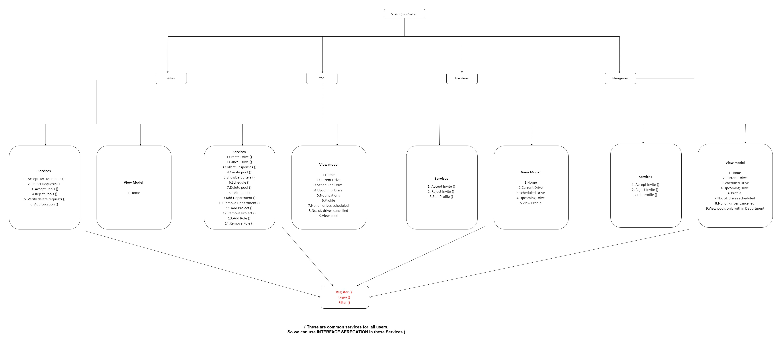

# **Modification History**

|  |  |  |  |
| --- | --- | --- | --- |
| **Date** | **Author(s)** | **Change Description** | **Version** |
| 19-04-2022 | TEAM ALPHA | Created Document | 1.0.0 |
| 20-04-2022 | TEAM ALPHA | Edited Alignments and Data Models | 1.1.0 |